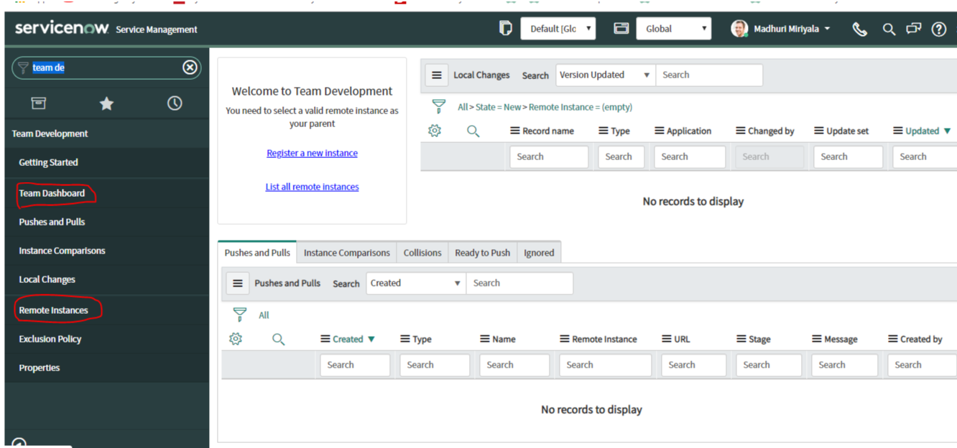

After configuring, the remote instance with crdentials, if you open Team Dashboard module , you will see the below screen with changes for pulling and pushing from or to parent instance. For suppose here I have added a field called linkedin ID in my instance which is captured i n local changes list as you can see. Though there are around 950 changes , I will send only few changes  as per requirement to the remote instance which is parent

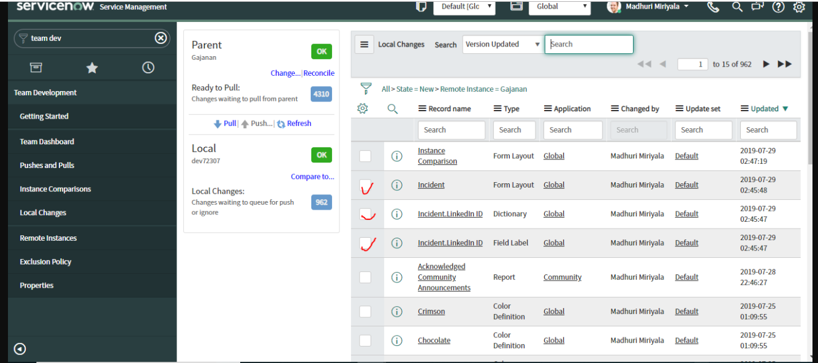

Now, you will be seeing the clickable Push button and number changes which are ready for pushing to parent instance

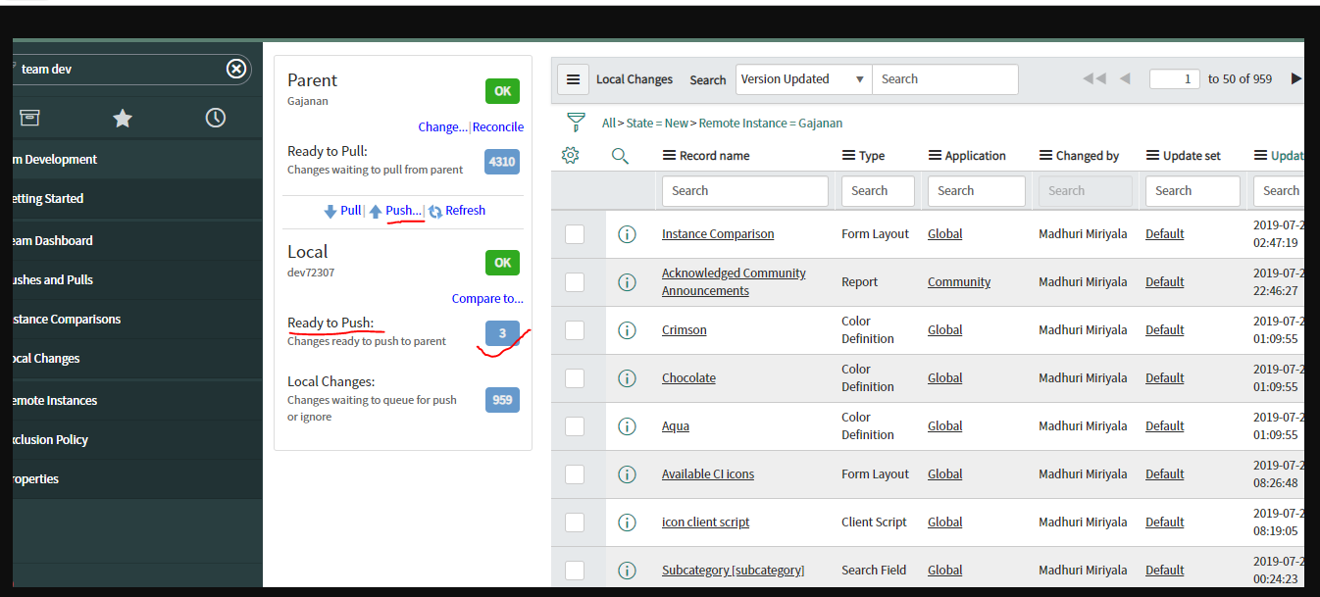

Clicking on Push button, will take you the below screen. After confirming , click on push changes UI Action

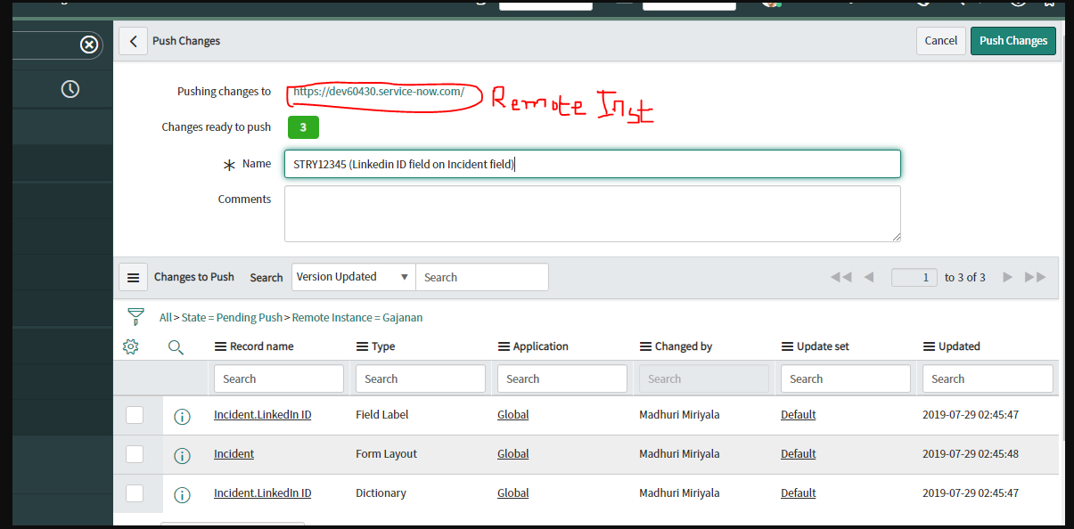

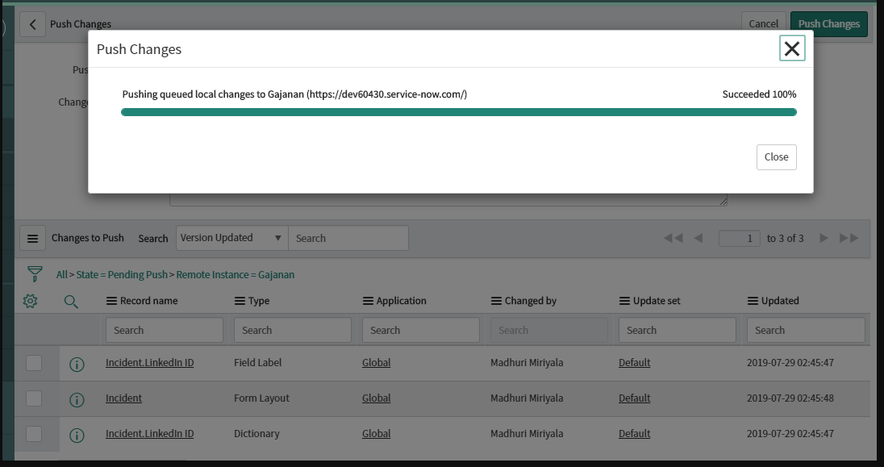

This is the parent instance, you can see the **linkedin ID** field on incident form which was pushed from other instance using team development

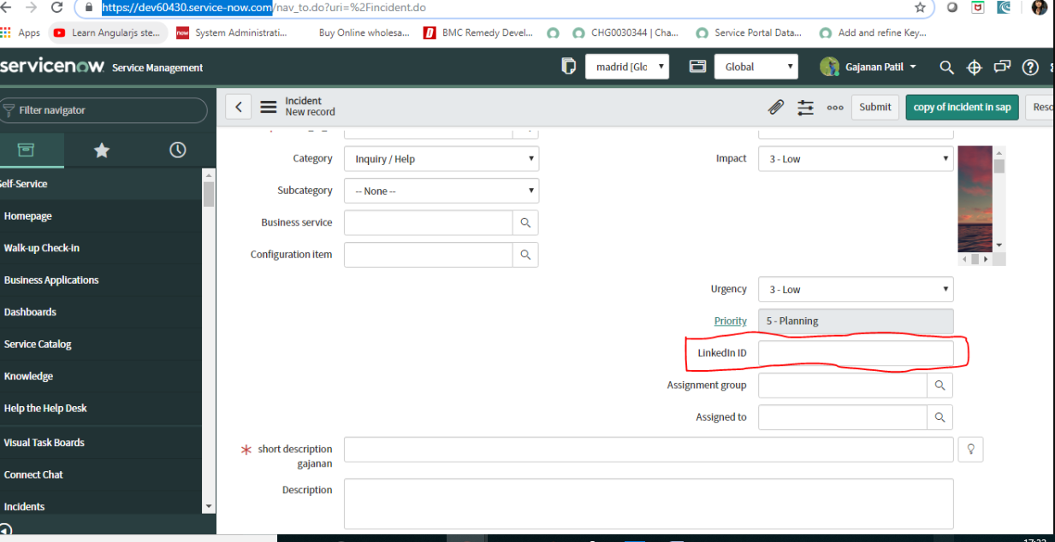

User can track the history of pushes and pulls from **Pushes and Pulls** module.

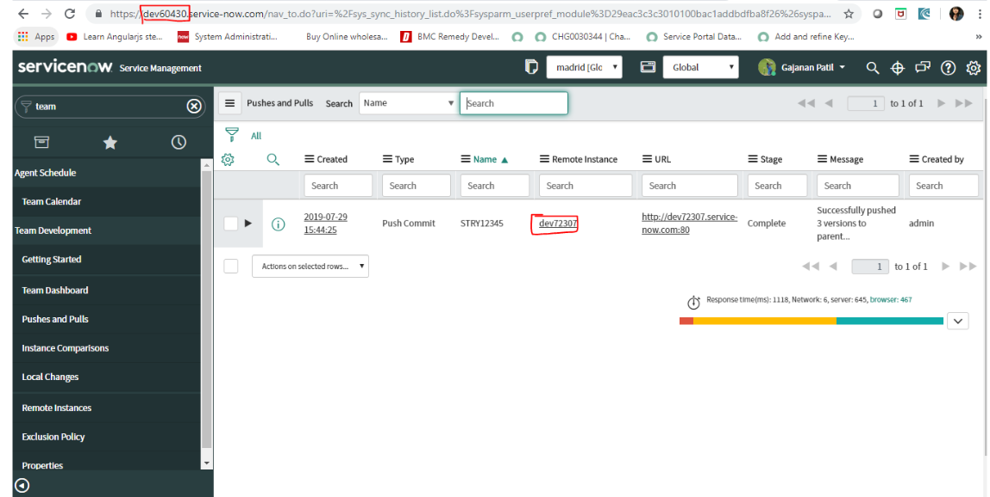

In the parent Instance, if you open the record you can see the entire details of the session. There is a option for backing out the changes also just like update sets.

